Lab Manual for TYBSc CS 2020-2021 USCS607:Ethical Hacking

RollNo: 18043

Practical No. 1

Date: 23/01/2021

**Aim:** Use Google and Whois for Reconnaissance.

**In charge Faculty Signature with date:**

**Step 1:** Go to Google.

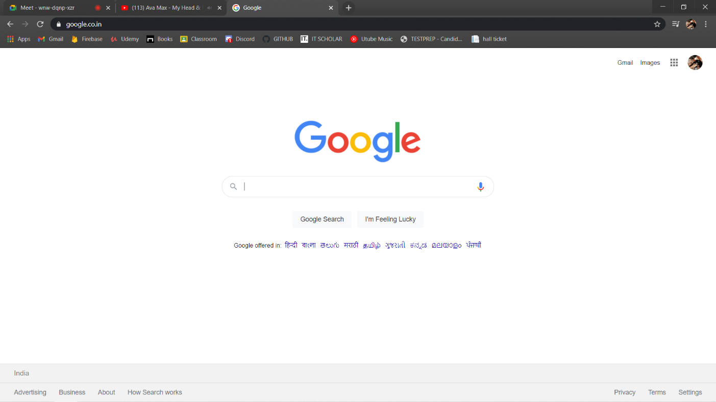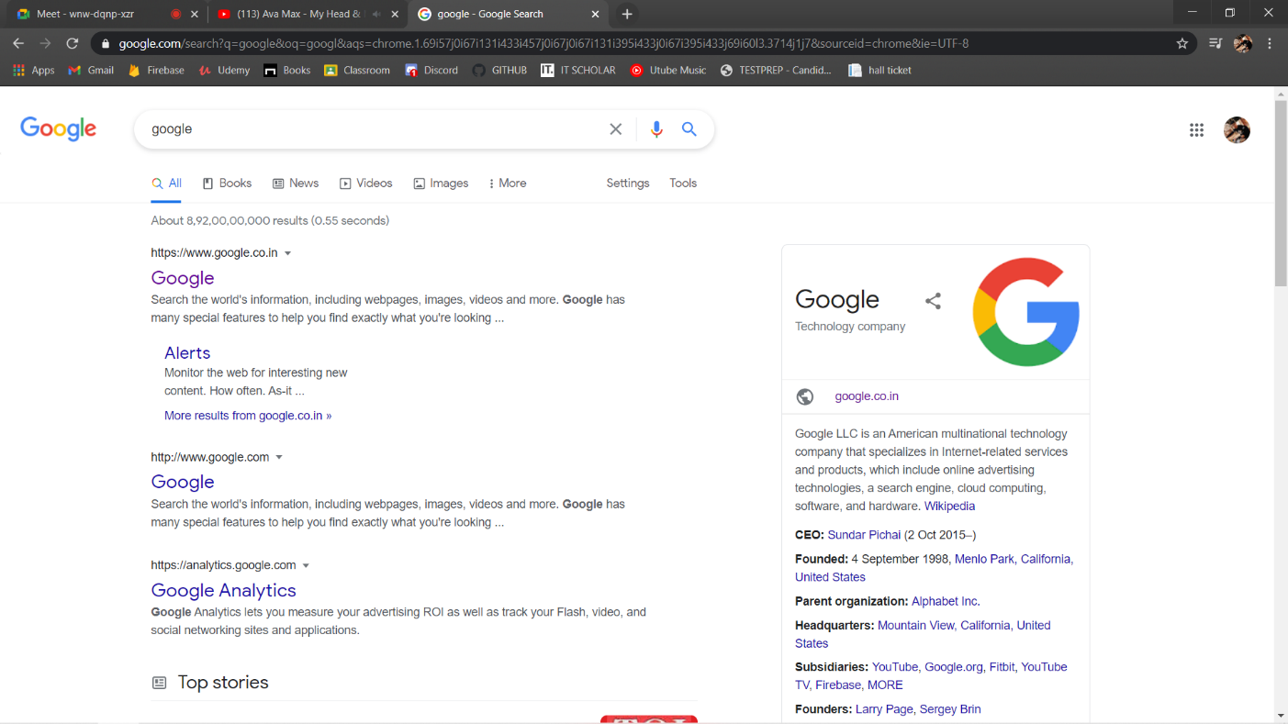

**Step 2:** Search for Whois

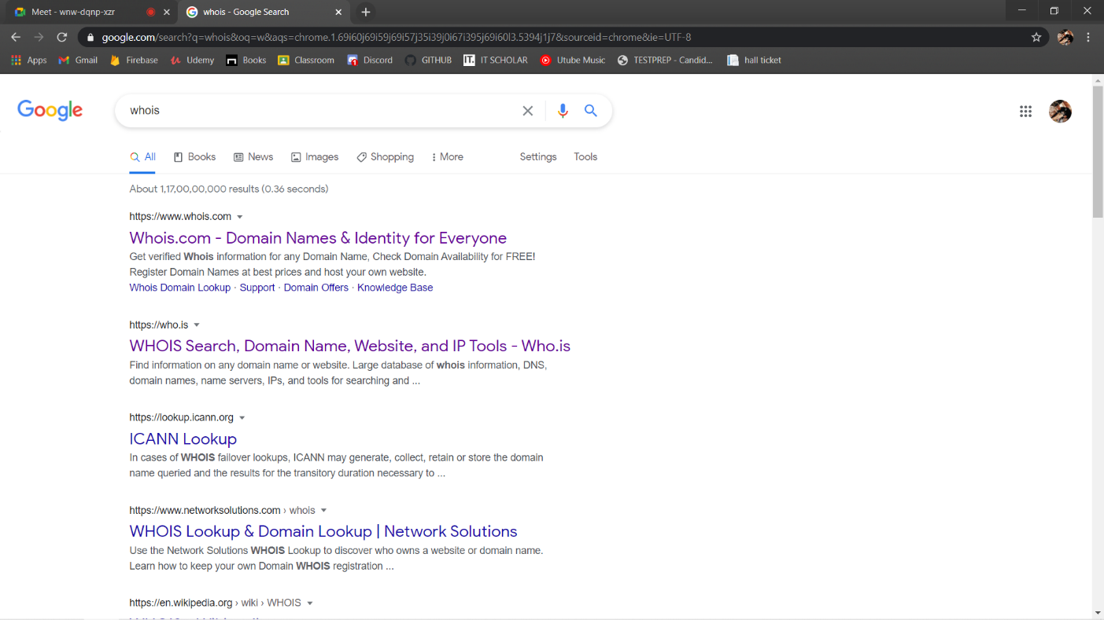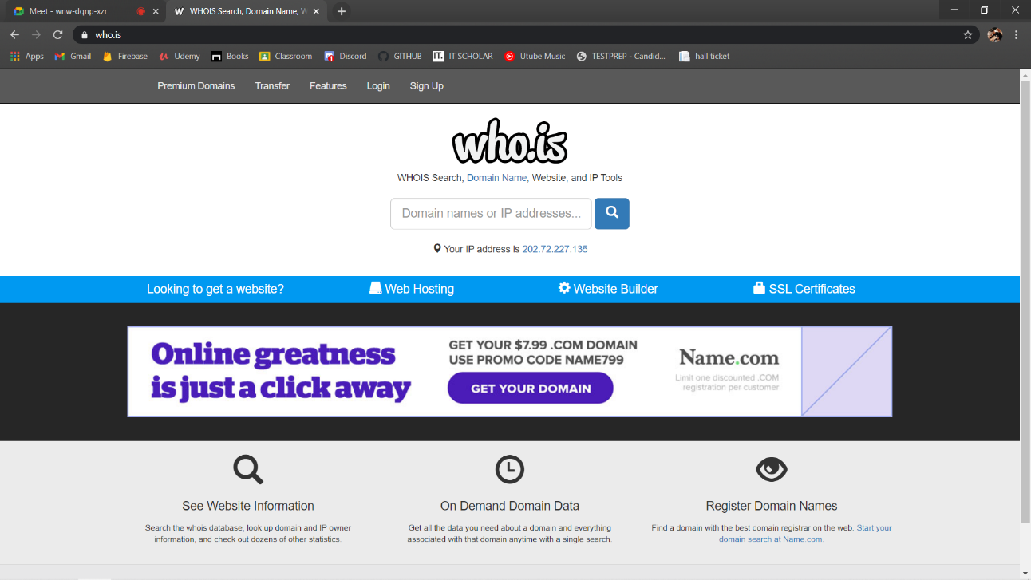

**Step 3:** In the search bar enter the website URL.

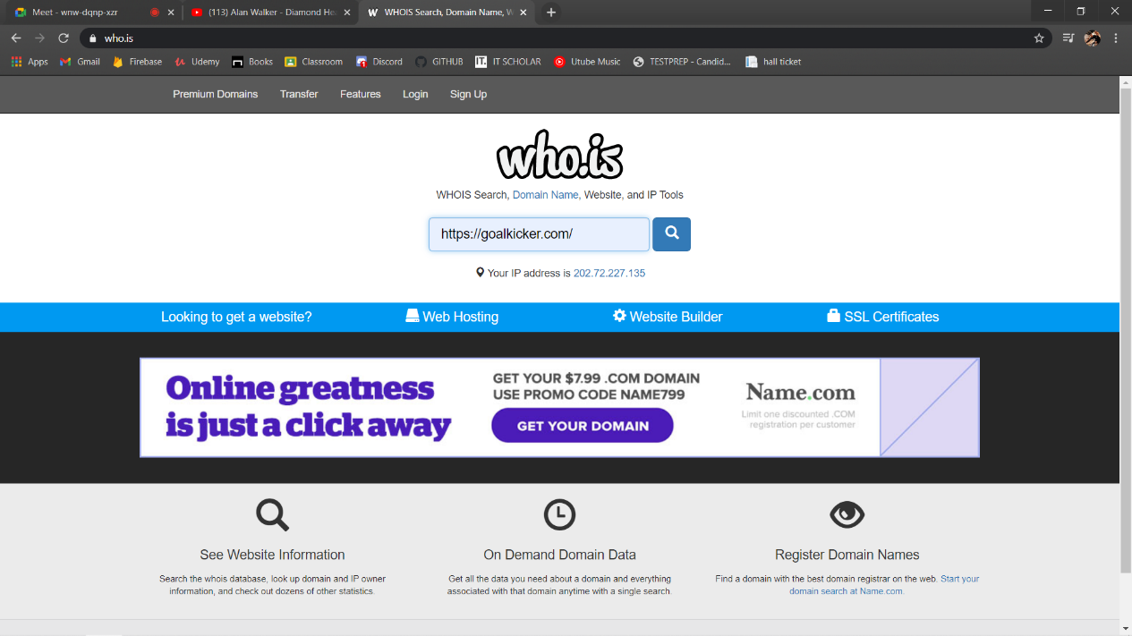

**Step 4:** You will get the details of the URL.

